PROJECT DEVELOPMENT
PERFORMANCE TESTING DOCUMENT
Auto Ticket Classification using Flow Designer

PROJECT & TEAM DETAILS
Project Title | Auto Ticket Classification using Flow Designer
Team ID | SWTID-2026-8882
Team Size | 5
Team Leader | VIJAYALAKSHMI S
Team Member | TAMILMANI K
Team Member | UTHAYAMALIYA K
Team Member | VAISALI G
Team Member | Vishalini S

1. TESTING OBJECTIVE
To verify that the Auto Ticket Classification workflow performs consistently and efficiently when processing representative ticket workloads.
2. TESTING SCOPE
- Workflow response time
- Repeated ticket processing
- Classification consistency
- Unmatched input
- Execution stability
3. TESTING WORKFLOW
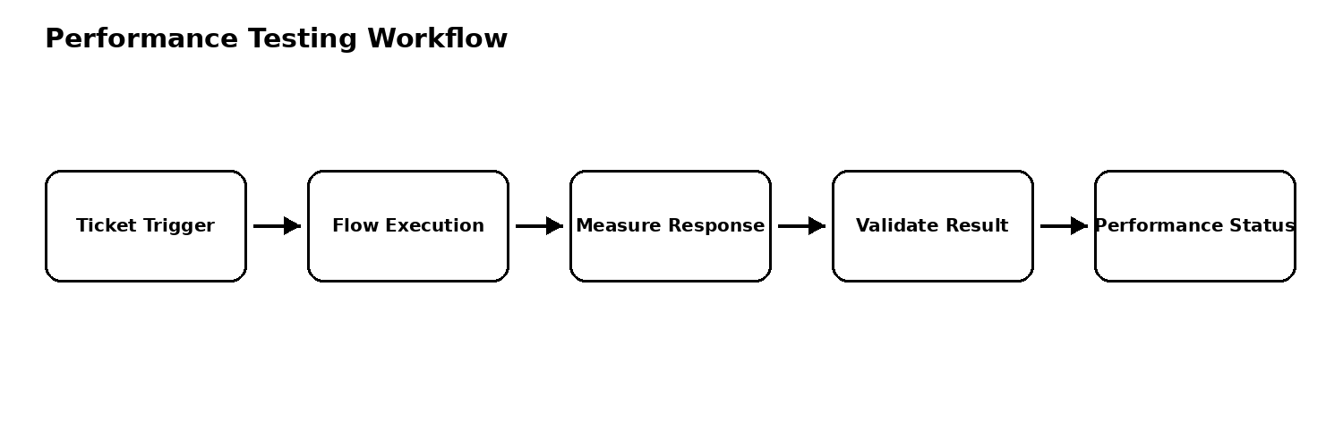
4. PERFORMANCE TEST CONDITIONS
- Use representative ticket data for repeated classification requests.
- Measure workflow response time from ticket trigger to completion.
- Observe successful executions, failures, and stability during repeated execution.
- Compare behavior under normal and increased ticket-processing load.
5. PERFORMANCE METRICS
- Response time
- Throughput
- Success rate
- Error rate
- Classification consistency
6. PERFORMANCE ACCEPTANCE CRITERIA
The workflow should process representative tickets consistently, complete within the project's acceptable response time, and avoid unexpected failures under the planned test load.
6. TEST CASES / ACCEPTANCE SCENARIOS
ID | Scenario | Input / Action | Expected Result | Status
PT01 | Single ticket response | Submit one valid ticket | Workflow completes within acceptable project response time | PASS
PT02 | Repeated ticket processing | Submit multiple valid tickets sequentially | Tickets process consistently without unexpected failures | PASS
PT03 | Different classifications | Submit tickets matching different rules | Each ticket receives configured classification | PASS
PT04 | Unmatched input | Submit ticket matching no rule | Default/unmatched handling completes without flow failure | PASS
PT05 | Sustained processing | Process representative batch | Workflow remains stable and results stay consistent | PASS
7. TEAM RESPONSIBILITIES
Role | Name | Responsibility
Team Leader | VIJAYALAKSHMI S | Test planning and coordination
Team Member | TAMILMANI K | Prepare representative ticket data
Team Member | UTHAYAMALIYA K | Monitor workflow execution
Team Member | VAISALI G | Record metrics and results
Team Member | Vishalini S | Review outcome and documentation
8. RESULT / SIGN-OFF
Overall Result: ____________________
Remarks: __________________________________________________________________
Approved By: ________________________ Date: __________________

